1. Goto [www.smc.edu/adobesign](https://nam10.safelinks.protection.outlook.com/?url=http%3A%2F%2Fwww.smc.edu%2Fadobesign&data=04%7C01%7CPHILLIPS_DANIEL%40smc.edu%7Cef080b545a864134180008d9d236eaeb%7Cbe95da8a67ab4574a292eeb9e5694a69%7C0%7C0%7C637771955585768369%7CUnknown%7CTWFpbGZsb3d8eyJWIjoiMC4wLjAwMDAiLCJQIjoiV2luMzIiLCJBTiI6Ik1haWwiLCJXVCI6Mn0%3D%7C3000&sdata=ZjTGTkq5sQePjauR2j1pspL9ABdkK9YzLU8hKckLHuM%3D&reserved=0)
2. Login to adobe sign with your SMC credentials
3. You will see this screen

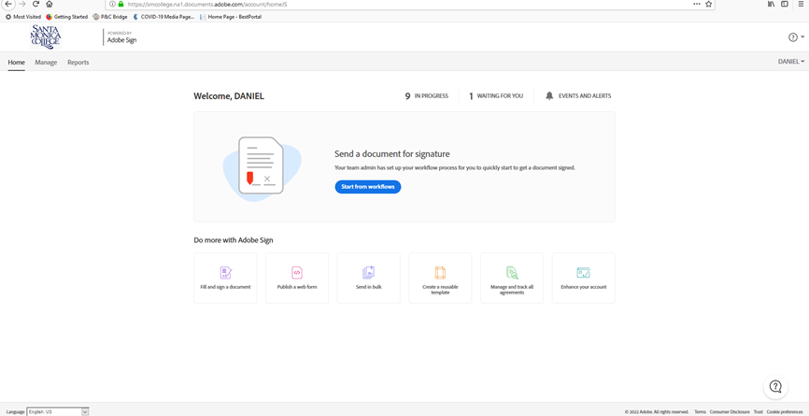

1. Click on start from workflows
2. You will see this pop-up window

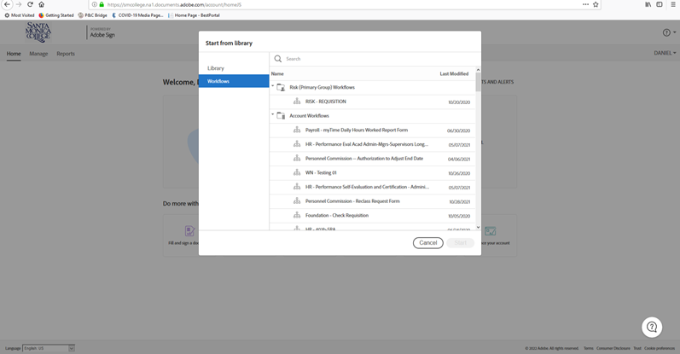

1. In the search box at the top type Risk. You will see this:

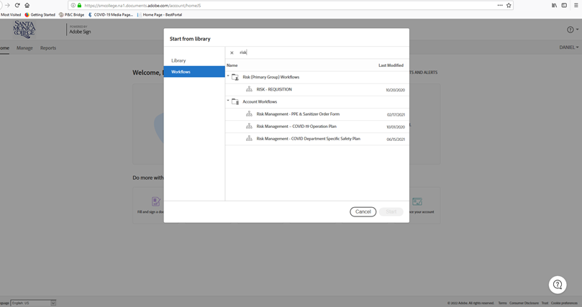

1. Click on Risk Management – PPE & Sanitizer Order Form, and then click START
2. Then you will see this window:

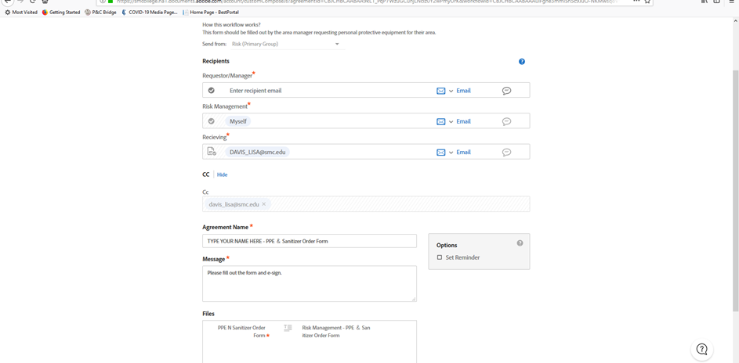

1. Under Requestor/Manager you can enter your email address; Under Agreement name, type your name where it says “TYPE YOUR NAME HERE”; then click **SEND**
2. The document will process and the request form will pop-up and you will see this:

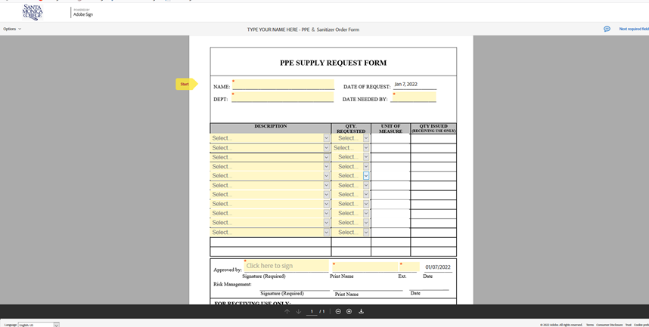

1. Enter your name, department and date needed by; select the type of PPE or sanitizer you want and the quantity; if the quantity is more than 10, you can repeat the same request on the next line. Keep in mind that a quantity of 1 usually means one box of something, not one unit.
2. At the bottom provide your signature, print your name and extension.
3. Once everything is filled in correctly there will be a pop-up bar at the bottom that says “Click to approve”.
4. The document now automatically goes to Daniel Phillips for approval. If Daniel Phillips approves, the document automatically goes to Lisa Davis in receiving to process and deliver your order. If Daniel Phillips does not approve you will receive an email that he did not approve and a message from him stating what needs changing in the document. If changes are necessary, start again from step 1.