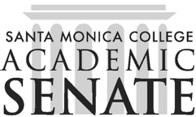

Santa Monica College Elections & Rules Committee

Meeting Minutes
Date: 3/24/2022
Time: 1500
Location: Zoom https://cccconfer.zoom.us/j/92445509021

Call to Order/Approval of Agenda

Public Comments
No public present

Approval of Minutes
Approved Feb 2022 minutes

Action Items

Timeline for Senate Officer elections

Process for forum questions: Faculty will be surveyed for input.

Draft nomination letter to be sent March 28 (Week 7)

Discussion Items

De-brief on election process for Senate, At-large Senators and Curriculum

Adjournment
@1537

For all documents, visit www.academicsenate.com
Next scheduled meeting: Monday, April 25@ 1500

