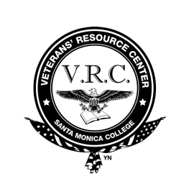 | CONTINUING STUDENT CHECKLIST

Continuing SMC Veteran Students with VA Benefits

- Log on to Corsair Connect check your enrollment appointment date and time
- Enroll in Classes on your appointment date and time (be sure that the classes you select are coming directly from your educational plan. If you do not have an educational plan, please follow Step 3 below).
A. Go to SMC Webpage www.smc.edu, tabs: current students, corsair connect, login, enrollment)
B. Select semester for which you want to enroll
  - Click add a class for left side
  - Click on search icon, find your course, select it
  - Visit the VRC located in the liberal arts building room 135
  - Fill out a Certification Agreement Form.pdf
  - If you add or drop any classes listed on your Certification Agreement form, you will need to let the certifying official know immediately by filling out an Agreement Change Form.pdf. Failure to do so may result in garnished VA payments.
- If you do not have an educational plan on file with the VRC or you have enrolled in courses that are not listed on your educational plan
  - Visit the VRC located in the liberal arts building room 135, see a Veteran Counselor to create an educational plan or update your existing educational plan.
  - Fill out a Certification Agreement Form.pdf
  - If you add or drop any classes listed on your Certification Agreement form, you will need to let the certifying official know immediately by filling out an Agreement Change Form.pdf. Failure to do so may result in garnished VA payments.
- Apply for financial aid (Once every academic year. Normal start of the application period is January of each year for the following academic year)
  - Go to FAFSA Webpage www.fafsa.gov, select "Start Here" to log in and you will be given the option to complete a FAFSA Renewal that has much of your application data from last year.
  - You will need your Federal Student Aid PIN to access your FAFSA on the Web application. If you have forgotten your PIN, you can request a duplicate once you login.
  - Remember to apply before your deadlines. Select "Deadlines" at www.fafsa.gov for specific deadline information.
  - If you have questions about your FAFSA, online help is available. Visit www.fafsa.gov and click the "Browse Help" feature on the FAFSA home page for answers to frequently asked questions and for additional information about the FAFSA process.
Continuing SMC Veteran Students with VA Benefits Webpage link:
http://www.smc.edu/StudentServices/VeteransResourceCenter/Pages/Continuing-Student-Checklist.aspx

